Deputy Premier receives Turkish Ambassador
02 : 06 PM - 30/01/2014
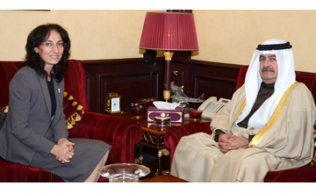
Manama: Jan. 30 – (BNA): Deputy Premier His Highness Shaikh Ali bin Khalifa Al Khalifa received the Ambassador of the Turkish Republic to the Kingdom of Bahrain, Hatun Demirer.
His Highness welcomed the newly-appointed Turkish Ambassador, wishing her success in the duties of her diplomatic assignment in order to bolster the historic friendship and cooperation bonds between the two countries and peoples.
His Highness praised the level of growth and development attained in the bilateral cooperation relations in the economic, commercial, investment and cultural fields.
The Turkish Ambassador expressed her utmost gratitude and appreciation to His Highness the Deputy Premier lauding his attentiveness and hospitality throughout their meeting and said that she would work to develop and boost her country’s relations with Bahrain in all that aspects which serve the interest both friendly countries and peoples. (IY)

