Hala Al Ansari receives Turkish Ambassador

06 : 50 PM - 30/01/2014
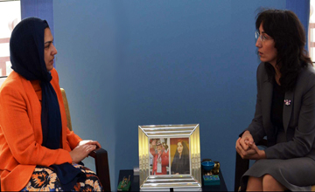
Manama, Jan. 30. (BNA)-- The Secretary General of the Supreme Council for Women (SCW ) Dr. Hala Al Ansari received here today the Turkish Ambassador to Bahrain Mrs. Hatun Demirer.
Al Ansari discussed with the Turkish Ambassador ways to support the National Strategy for the Advancement of Bahraini Women through benefiting from the Turkish experience in supporting women and helping them reach decision-making positions.
She briefly reviewed SCW’s efforts in implementing the National Strategy for the Advancement of Bahraini Women, adding that she is looking forward to expanding the horizons of bilateral cooperation and exchanging of expertise in the field of women's work and awareness of their rights.
Mrs. Hatun Demirer praised the efforts of SCW, led by Her Royal Highness Princess Sabeeka bint Ibrahim Al Khalifa, Wife of His Majesty the King and President of the Supreme Council for Women, as one of the pillars of the Reform Project, spearheaded by His Majesty King Hamad bin Isa Al Khalifa, affirming that the SCW has played a great role in supporting Bahraini women to reach the highest decision-making position since its inception.

